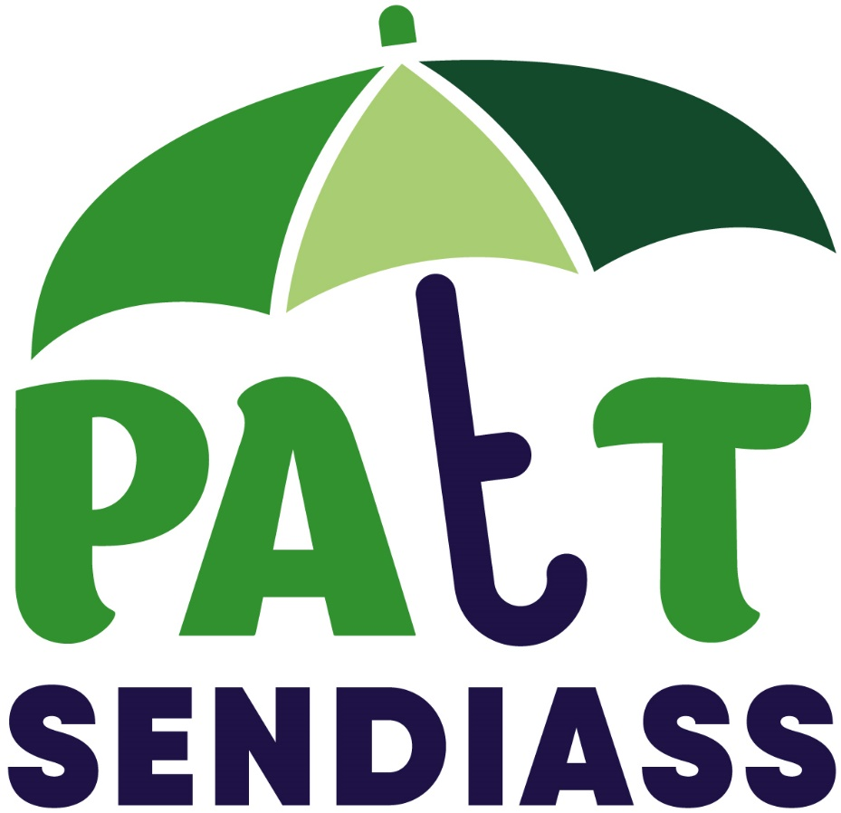

Preparing for Adulthood
Workbook
Yrs 9-11

Name:

Date of Birth:

Date Completed:
Scribed by:

NOTES FOR PARENTS AND PROFESSIONALS SUPPORTING YP TO COMPLETE THIS DOCUMENT
When starting this workbook, do not rush it. For many young people, thinking about their future can be overwhelming and tiring. They need time to process the questions and consider their answers. It is probably best done in hour long sessions over the course of a week or so. Please do not leave your young person to complete this by themselves. These are big questions and difficult concepts which need discussion.
It is important to remember when helping a YP complete this document, that if you are scribing for them, always use their words. Do not be tempted to re-word it. It is their document, and it is their voice that we are interested in. If their ambition is to win the lottery, whilst we cannot help them achieve that, it is still their ambition. It may be the starting point for a conversation about what they would do with the money and maybe, how we can achieve some of those things without hitting the jackpot. There are no wrong answers, there are no silly ambitions. If a YP with physical limitations has aspirations to be a police officer or firefighter, that should not be dismissed as un-realistic, but the start of a conversation about why they are attracted to that career path (is it wanting to help people? wanting to wear a uniform? etc.) and would other roles within those organisations be of interest to them. We are all entitled to our dreams.
The list of skills under each heading are a starting point, we have left some space to add your own. If a young person feels that there are many of those skills that they would like to work on, help them prioritise which are the most important (and doable) for this year. Success is always a motivator.
Professionals – please remember that PfA outcomes should not be restricted to the PfA page of the EHCP. From Year 9 (at the latest) and beyond, outcomes in Section E should all have a link (directly or indirectly) to that young person’s PfA as they must be linked to the YP’s aspirations (see the Golden Thread). These short-term goals/aspirations must have provision to help the young person achieve them. The achievement of these outcomes should not be left to parents/carers to work on. Provision within Section F of the EHCP is the responsibility of the local authority, delegated to the school or college. If there is a need and an associated outcome, there must be provision to address that. If you are struggling to find provision for particular PfA outcomes, contact senpfa@thurrock.gov.uk or info@patt.org.uk for support and guidance.
The PATT website www.patt.org.uk/resources has many different worksheets for young people to complete which will help them think about their strength and aspirations.
As a service, PATT can offer training and support to young people, parents and professionals on getting the best from this process and Preparing for Adulthood generally. Please contact info@patt.org.uk for details.

What is Preparing for Adulthood?
From Year 9 onwards, everyone supporting you in school and college need to focus on how we prepare you for adulthood, thinking about how you want to live your life, what kind of job you would like, living independently, accessing hobbies, clubs and meeting people and your health and wellbeing. To do this well, it needs school/college, other professionals who work with you, and parents/carers to work with you to find out what is going well, what you want to change and how you want to live as an adult. What you want for your future is the starting point for all meetings and reviews and you must be at all meetings that discuss your future.
So that we can think about the four areas of preparing for adulthood, we need to think about your aspirations, your abilities, and your outcomes and link them all together to make a plan for your future. But first, it is a good idea to think about your education so far. What has worked, what doesn’t work for you and how you want to be supported in future to achieve your goals and ambitions.
Employment/Education:

Understanding college options, exploring different employment options, such as internships, apprenticeships, and help from supported employment agencies, becoming self-employed.

Independent Living:

Young people having freedom, choice and control over their lives, their support, and their accommodation and living arrangements, including supported living. Having skills and knowledge to live as independently as they are able.

Health and Wellbeing:

Knowing how to look after your health, being able to access doctors, dentists, hospitals. Support, if necessary, to access exercise and healthy eating.

Community Inclusion:

Having friends and supportive relationships, going out, being part of your local community being able to pursue hobbies and interests.

My Thoughts about
What/who is important to me? (also see Circles of Support)
In School | Outside of school (friends, hobbies)
What has gone well for you
In School | Outside of school
What do you find difficult at school? What help would you like and how do you want people to help you?
What I find Difficult | What help I would like

My Thoughts about
What makes me happy
In School | Outside of school
What makes me sad or angry
In School | Outside of school (friends, hobbies)
Things I worry about

What is an Aspiration?
The Dictionary says an aspiration is
a long-term hope or ambition of achieving something.
Why does everyone talk about my aspirations?

Your hopes, dreams and aspirations should be where we start when we think about your future after school. It is much easier to plan a route if you know where you want to go. You may have a mix of aspirations, some easily achievable, some may be more difficult, and some may be best described as fantasy. It doesn’t matter, there are no wrong answers, it is about what YOU aspire to. It is important to think about what help you need to make your life what you want it to be.

Why is it important to think about my aspirations?

When we are writing or reviewing your Education, Health and Care Plan, your aspirations are in Section A. This is the first thing we need to think about and talk about at the meeting. Without knowing what your aspirations are and what is important to you we cannot accurately complete the document or help you make plans for your future.

Examples of Aspirations

See My Hopes Dreams and Aspirations example document below.
Go to www.patt.org.uk/resources to see examples of worksheets you could use to share your views
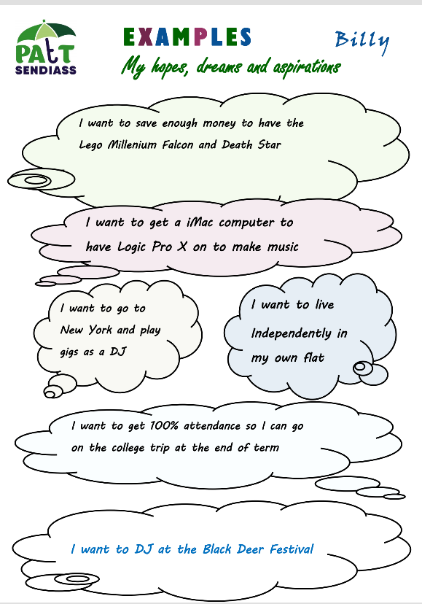

My Hopes, Dreams
and Aspirations
This section can be broken down in to:
1. Long Term Goals (things you want to achieve as an adult, such as, your dream job, your dream holiday or just the everyday things you want to be able to do for yourself). There should be no limits to your aspirations. Think Big, Dream Big!
2. Short Term Goals (things you want to achieve in the next12 months, this may include college courses, or skills you need to achieve your Long-Term Goals).
You may have a goal for each of the 4 areas on the last page (you may have more; you may have fewer)

My Long-Term Goals and Aspirations |  | What I want to achieve in the next 12 months
What is my current skill set?
What is a skill set?

The Dictionary says a skill set is:

A person’s range of skills and abilities

Why is it important to think about my skill set?

When we are writing or reviewing your Education, Health and Care Plan or one-page profile there should be a focus on your strengths and abilities. As you come to think about what you want to do when you leave education is important to think about the things you can already do as well as the things you still need to learn.

Why are my strengths and abilities important?

It is good to think about things that you are good at or that you enjoy and what you could do with these as an adult.

Thinking about skill sets

There are different types of skill sets, sometimes they are broken down into “soft skills”, “hard skills” and “transferable skills”:

Soft skills are sometimes called “people skills”. These can include, good communication skills, listening, attention to detail, problem solving skills, good time keeping, empathy and working well as part of a team. If these are things you find difficult, you may want to consider setting one of these skills as an objective at your review.

Hard skills are things that can be taught and learned. Examples of hard skills include maths, computer skills, accounting, plumbing, languages and driving.

Transferable skills are soft skills like being good at organising your Pokémon cards or remembering all the Premier League clubs and being able to use those abilities as job skills, for instance, having a good memory would be useful when working in a café or shop. Sometimes you may not realise that your “quirks” are skills that could be transferred into a work environment so it is really important that you talk to others about the things you are good at and how they may be “transferrable”.

My skill set
What are my current skills?

^{Soft Skills} | ^{Hard Skills} |  | ^{Transferable Skills}

What is an Outcome?
The Dictionary says an outcome is:

How something turns out in the end. The final product or result.

Why does everyone talk about my outcomes?

When we are writing or reviewing your Education, Health and Care Plan there is a lot of talk about outcomes because it is important to think about what you would like to achieve as an adult.

Why are my outcomes important?

Your outcomes are important for you to be able to achieve what you would like to as an adult.

How can I think of my outcomes?

So that you have a plan for achieving your aspirations, we need to think about the things, or the steps along the way that you will need to be able to do or learn.
Again, we will break them down into the 4 areas of Preparing for Adulthood and think about why these things are important to you and what difference it will make to your life to be able to do them.

Do my outcomes connect to my aspirations and skill set?

The outcomes that you set at your planning meeting or annual review should be directly linked to your aspirations and what skills you wish to work on to be able to achieve your aspirations or a smaller goal on the way to your bigger aspiration. Provision is how we are going to help you achieve your outcomes. They will be discussed at the review meeting. It is important when we are thinking about aspirations and outcomes that they join up. It is often called the “Golden Thread”.

A good example of the Golden Thread

Aspiration: Billy would like to buy himself some “big Lego”. He would especially like to buy the Lego Millennium Falcon
Skill required: Billy needs to be able to budget his monthly income better and needs to be able to prioritise his spending
Provision (what we need to do to help you learn the new skill): Billy will work with a support adult on a Money Skills programme to learn about budgeting and prioritising his cash, including keeping a spending diary to keep track of his spending. He will also learn how to find the best price for something e.g. internet, different shops etc.
Outcome: Billy is now able to budget and use his money efficiently by deciding what is most important for him and to him. He is saving regularly and is on track to having enough savings to buy the Millennium Falcon by June 2021.

My Outcomes
Employment/Education
What you would like to be able to do or learn that will help you achieve your goals and aspirations?
We have a list of things below to help you think about skills you may need, or you can add your own.
In the box on the right grade each question:
1 Don’t know 2 I know and am confident to do this independently
3 I know but am not confident to do this on my own 4 Not interested at the moment

Do I know about college courses?
Do I know which colleges may be suitable?
Do I know what grades I may need?
Do I know what help I can get at college?
Do I know what qualifications I may need for my chosen career?
Do I know how I find out about apprenticeships?
Do I know how far I will have to travel to get to college?
Do I know where to get careers advice?
Am I confident using computers and the internet?
Outcomes I’d like to work on during the next 12 months | Why is this important? What difference will it make to your life to be able to achieve it?

Independent Living
What you would like to be able to do or learn that will help you achieve your goals and aspirations.
We have a list of things below to help you think about skills you may need, or you can use your own.
In the box on the right grade each question:
1 Don’t know 2 I know and am confident to do this independently
3 I know but am not confident to do this on my own 4 Not interested at the moment
Can I get myself up for school?
Can I remember to take the right stuff with me?
Can I use public transport independently?
Can I go to the shop by myself?
Can I dress appropriately for the weather or activity?
Can I cook a simple meal?
Can I follow a recipe?
Can I clean and tidy up after myself?
Can I change my bedding?
Can I tell the time on different types of clocks?
Do I know how to organise my time?
Do I know how to budget my money?
Outcomes I’d like to work on during the next 12 months | Why is this important? What difference will it make to your life to be able to achieve it?

Health and Wellbeing
What you would like to be able to do or learn that will help you achieve your goals and aspirations. We have a list of things below to help you think about skills you may need, or you can use your own.
In the box on the right grade each question:
1 Don’t know 2 I know and am confident to do this independently
3 I know but am not confident to do this on my own 4 Not interested at the moment

Do I know how to eat and drink healthily?
Do I know who my doctor is?
Can I manage my own medication (remember to take my tablets)?
Do I know about Annual Health checks and how to arrange one?
Do I know what to do if I cut or badly hurt myself?
Do I know how to call 999 and say what is wrong?
Can I keep my bedroom clean and safe?
Do I know how to calm myself if I am getting too angry, upset, or worried?
Do I know who I can talk to if I feel worried or really upset?
Do I know where to get advice about alcohol, drugs, or sex?
Do I need prompts or reminders to follow personal hygiene routines
Do I need help with personal hygiene (brushing my teeth, washing, or showering, putting on deodorant, cutting my own finger and toenails)?
Outcomes I’d like to work on during the next 12 months | Why is this important? What difference will it make to your life to be able to achieve it?

Community Inclusion
What you would like to be able to do or learn that will help you achieve your goals and aspirations. We have a list of things below to help you think about skills you may need, or you can use your own.
1 Don’t know 2 I know and am confident to do this independently
3 I know but am not confident to do this on my own 4 Not interested
Do I know how to keep in contact with my friends?
Do I know how to find new friends?
Do I know what a makes a good friend?
Do I know who to talk to or what to do if I feel lonely?
Do I know how to find out about clubs and groups that may interest me?
Do I know how to stay safe on the internet?
Do I know what personal information is?
Do I know who it is safe to share personal information with?
Do I know how to stay safe whilst out and about?
Am I comfortable speaking with people in shops/asking for help?
Do I know how I can get support to go out and have fun?
Outcomes I’d like to work on during the next 12 months | Why is this important? What difference will it make to your life to be able to achieve it?

My Circles of Support
Circle 2 – My friends
This circle includes people who are good friends, people we would go to the cinema with or meet up with for lunch or go for a drink with.
Circle 1 – People who love me
This “inner” circle is made up of people we love and who love us, people we feel safe with – including very close family members and very close friends.

Layout not suitable for completing online. Please print this page. A3 version available

me

Circle 3 – People I know and interact with
This circle includes acquaintances from different areas of our lives – school, college, church, choir, social clubs, shopkeepers. Over time, some people from this circle may move into your friendship or inner circles.

Circle 4 – People who work with me or for me
This circle includes people who are paid to be in our lives – Doctors, teachers, LSAs, support workers, etc. Usually, these relationships are purely professional, but you may consider someone like your support worker to be in your friendship or inner circle too.

Useful Contacts & Information
PATT SENDIASS | www.patt.org.uk  info@patt.org.uk | 07702 127 252
Thurrock Local Offer | www.askthurrock.org.uk
SEN Department Pre 16 | www.thurrock.gov.uk  sen@thurrock.gov.uk | 01375 652 555
SEN Education Preparing for Adulthood Team | www.thurrock.gov.uk  senpfa@thurrock.gov.uk | 01375 659 648
Thurrock Social Care Preparing for Adulthood Team | www.thurrock.gov.uk  transitionspfa@thurrock.gov.uk | 01375 652 547
Inspire Youth Hub | www.thurrock.gov.uk  inspireyouthteam@thurrock.gov.uk | 01375 413 735
Thurrock Opportunities | www.thurrockopportunities.co.uk
Thurrock Careers | thurrockcareers@thurrock.gov.uk | 01375 413 735
South Essex College Student Support Team | email: additionallearningsupport@southessex.ac.uk  Karen Fox  Head of Additional Learning | 01375 362 601
USP Palmers College Student Support Team | Julie Snelling  Head of Additional Learning  info@uspcollege.ac.uk | 01268 646 786
Thurrock Adult Education College  High Needs Learner Team | Rachel Goodall  Programme Manager  r.goodall@tacc.ac.uk | 01375 372 476  extn 255
Information on Benefits | Contact  https://contact.org.uk/help-for-families/information-advice-services/benefits-financial-help | Contact helpline  0808 808 3555

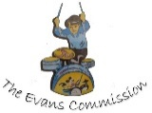
The Evans Sessions
Each half-term we hold (on Microsoft Teams until we are able to hold face to face meetings again) information and training sessions for parents and carers focusing on Preparing for Adulthood. The young people themselves are welcome to attend.

Each month will focus on a particular theme e.g. Education (college, apprenticeships, work experience) or Finance (direct payments, benefits etc).There will also be members of Education, Social Care and the PATT service to answer any queries or make appointments for further assistance.

You can get the link to the session, as well as more details on the topics and speakers by
going to www.patt.org.uk/evans-commission

